**Simplilearn Phase Four Project**

**Kitchen Story**

**Core Concepts: Technologies used**

* Angular: used in the front-end side to build modern single-page applications
* HTML/CSS: to create and format the content of the pages.
* Visual Studio Code: to write and run the Angular code.

**Frontend**

# KitchenstoryFrontend

This project was generated with [Angular CLI](https://github.com/angular/angular-cli) version 12.1.4.

## Development server

Run `ng serve` for a dev server. Navigate to `http://localhost:4200/`. The app will automatically reload if you change any of the source files.

## Code scaffolding

Run `ng generate component component-name` to generate a new component. You can also use `ng generate directive|pipe|service|class|guard|interface|enum|module`.

## Build

Run `ng build` to build the project. The build artifacts will be stored in the `dist/` directory.

## Running unit tests

Run `ng test` to execute the unit tests via [Karma](https://karma-runner.github.io).

## Running end-to-end tests

Run `ng e2e` to execute the end-to-end tests via a platform of your choice. To use this command, you need to first add a package that implements end-to-end testing capabilities.

## Further help

To get more help on the Angular CLI use `ng help` or go check out the [Angular CLI Overview and Command Reference](https://angular.io/cli) page.

**Screenshots:**

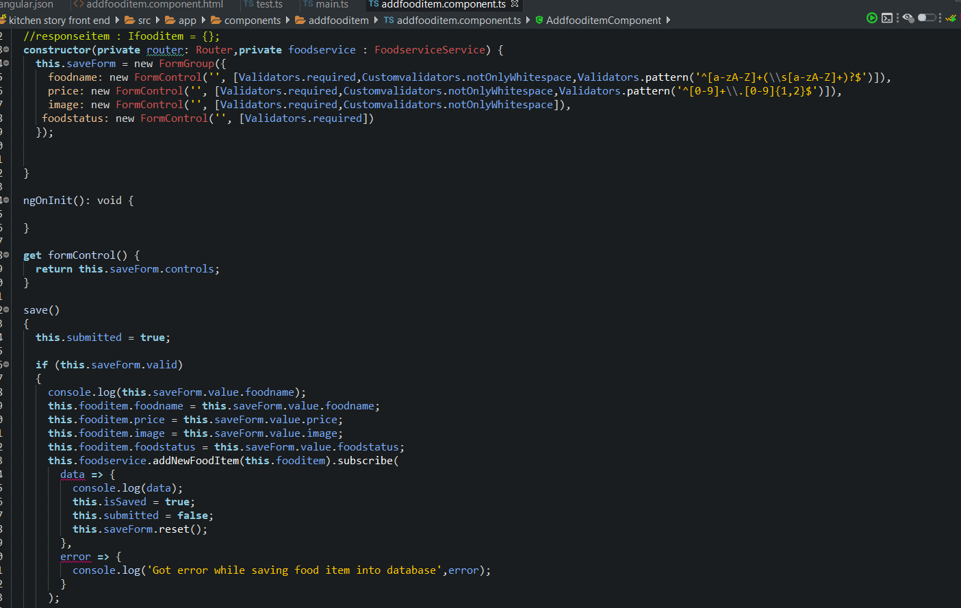

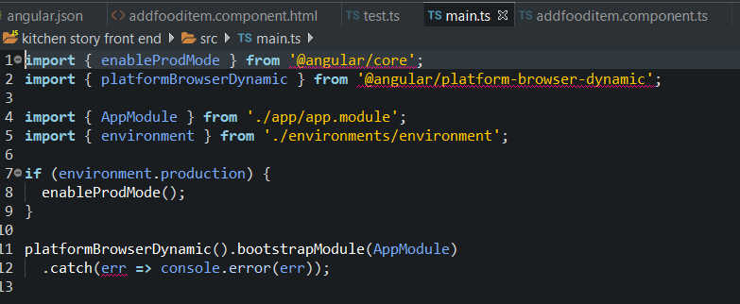

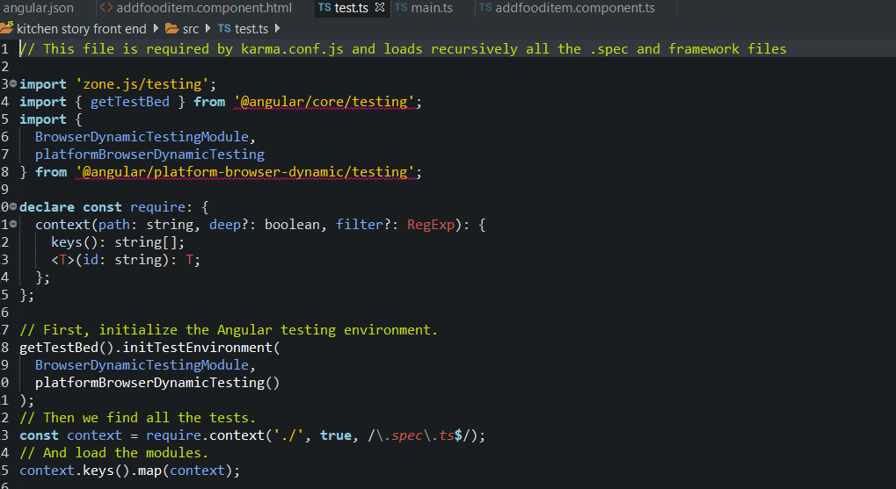

**GitHub Repository:**

**The code repository for this project is available at GitHub:** <https://github.com/badrilogaram/Phase-One-Project>